
Hobs Moat PRG


Newsletter Christmas 2019

The PRG would like to wish all patients and practice staff a Very Merry Christmas and a Happy New Year

CHAIR’S NEWS :
APPOINTMENTS
Winter is here again, and we all know with it comes strain in the NHS, not just in hospitals but in our GP surgeries too. We can all help to relieve that strain by trying to look after ourselves that little bit more, leaving doctors’ and nurses’ appointments for those who may need them more than we do. Some ways we can all help:
Visit a pharmacy for professional advice and over the counter medicines.
Telephone – 111 for advice at any time including when the surgery is closed.
NHS Website – www.nhs.uk/staywell – for information on winter ailments and much more.
A&E and 999 are for life threatening serious illness and injury ONLY.
PRESCRIPTION ORDERING
The last date for ordering prescriptions before Christmas is Wednesday, 18th December – DON’T BE CAUGHT OUT!
COUGHS, COLDS & FLU
Please see overleaf for a few tips on how to stop these infections from spreading.
VIDEO CONSULTATIONS
Who thought this would ever happen? Well, it’s coming to Hobs Moat Medical Centre very soon. Dr Malde is the ‘lucky’ doctor who has been designated our ‘Digital GP Lead’; he is very enthusiastic about this new concept and is hopeful that video consultations can be trialled early in the New Year. WATCH THIS SPACE…!
In preparation for this innovation, and in order to gain patient input, Dr Malde put in place a patient survey; more than a hundred patients took part and on Dr Malde’s behalf I would like to thank you all for your time and your comments. Your input is very much appreciated, and will really help to shape this exciting new service.
Joyce MacNichol – Chair
JUST FOR FUN – CHRISTMAS QUIZ
1 How many Christmas dinners did Geraldine, ‘The Vicar of Dibley’, attend in the 1996 Christmas special?
2 Who had a Christmas hit with ‘Mistletoe and Wine’ in 1988?
3 Which plant with red and green foliage, indigenous to Mexico, is widely used in Christmas floral displays?
4 Balthazar and Caspar were two of the kings (or wise men) to visit the baby Jesus, who was the third?
5 Before decimalisation in 1971 – what was the traditional coin cooked in a Christmas pudding?
6 ‘Gaudete’ a 16th century Christmas carol (remember Steeleye Span) refers to which Sunday in Advent?
7 Who invented the Christmas cracker?
8 Which American film released in 1942 contained the song ‘White Christmas’?
9 In which century was it decided that the birth of Jesus would be celebrated on 25th December?
10 It is claimed that which English king was the first person to eat turkey for his Christmas meal?
 Answers →

Page 2
Hobs Moat PRG – Newsletter Christmas 2019
BE PREPARED
Make sure you have enough medication to last over Christmas and New Year, last order date for Christmas is Wednesday, 18th December

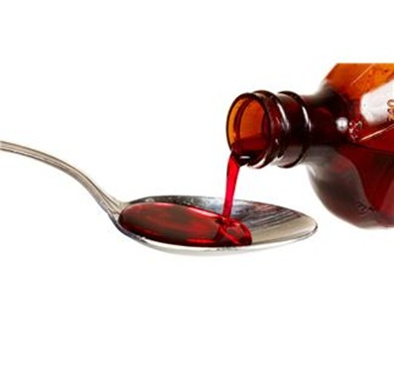COUGHS & SNEEZES SPREAD DISEASES:
Answers - Christmas Quiz
1 Four
2 Cliff Richard
3 Poinsettia
4 Melchior
5 Sixpence
6 Third Sunday
7 Tom Smith
8 Holiday Inn
9 4th Century AD
10 Henry VIII

If you start to feel unwell with a winter illness – cough, cold, flu etc. – don’t wait until it gets worse, go to your local pharmacy for help and advice.
Germs spread quickly and easily from coughs and sneezes, so use a tissue to trap those germs and stop infections from spreading.
BIN THE TISSUE as soon as you can.
 Catch it. Bin it. Kill it.
Germs can live on hands, and surfaces, for 24 hours, so it’s very important to wash hands often in warm water and with soap.
Sore throat – gargle with salt water (dissolve one teaspoon of salt in a glass of part-cooled boiled water). It won’t heal the infection but the solution has anti- inflammatory properties so should have a soothing effect.
KEEP WARM : KEEP WELL
Go to the NHS website for more tips on how to stay well this winter.
www.nhs.uk/staywell
COMMENTS AND SUGGESTIONS
If you have any ideas, comments or suggestions that you feel would improve the service you receive from the practice, then please let the PRG know – there is a box on the wall in the waiting room.
Flu Clinics 2019
As many of you will know, over the last few years PRG members have attended flu clinics to help the practice staff ensure the smooth running of those clinics. As last year, we helped with the Adult clinics.
I would like to thank those PRG members who gave their time to help; it is very much appreciated by practice staff and patients alike.
Many thanks to those patients who took the time to praise the efficiency of the clinics. It makes it all worthwhile.
My thanks to everyone.


There is a £20.00 John Lewis voucher available for any implemented suggestion.

